MAY 2021 NEWSLETTER AND CLASSES!
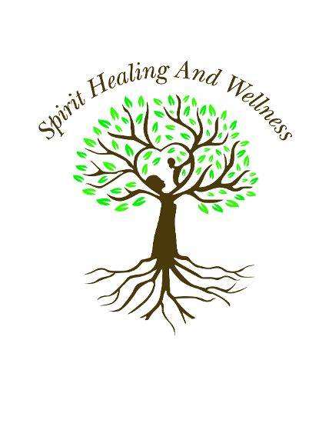
“May” is derived from “Maia.” Maia is the Goddess of Springtime, Growth, Fertility, Love, Increase, Birth and Success. Her name means “Mother,” and during May, Her Wisdom and Love are before you.
May is a month of immense opportunity, offering Clarity, Newness and Change!
In Eastern Medicine, Taurus rules the Large Intestines. What is needing to be released? What, or whom, are you holding on to? Mental Clutter, Frustration, Sadness and Grief are associated with this organ. Release the Old so the New may flow in…Happiness, Freedom and Peace of Mind await you upon releasing.
Numerologically speaking, the 5th month of the calendar year delivers the Gifts of “Change.” Freedom, Adventure, Curiosity and Fun are part of the "5 Vibration." It is Spirit expressing Itself through You…through the Gift of your 5 Human Senses.
From an Astrological perspective, Taurus rules “what’s yours.” Perhaps it’s a way of Living and Being…more aligned with your Higher Self. Perhaps it is Peace in the Body and Mind. Reflect upon your deepest desires… and determine "what’s yours" to be birthed.
Maia invites you to Mother yourself…to patiently, lovingly go within and attend to your Heart’s true callings.
To support you during the month of May, the following classes and services are offered:
“LIVING THE FOUR AGREEMENTS” – Uncover the thoughts, behaviors, patterns and mindsets that have unconsciously been determining your decisions, actions, happiness and Life. "Living the Four Agreements" teaches us to detach from drama, fear, judgment and pain, and brings Unity to the Heart and Mind. This is a 6-week class, beginning the 2nd week in May. Daytime and evening classes are available. Click here for detailed information.
Eclipse Season begins this Month, further supporting your Wisdom and Change!
Tuesday, May 11th – "NEW MOON IN TAURUS MEDITATION AND CLASS." Flyer available by clicking here.
Wednesday, May 26th – "FULL MOON LUNAR ECLIPSE IN SAGITTARIUS MEDITATION AND CLASS." Click here for details.
ONGOING THROUGHOUT THE MONTH – Energy Sessions, Health Education, Speaking Engagements, Coaching and Readings are available in person or via Zoom.
For additional information, please contact:
Lynn Pridmore
at 201-572-7771 or
Lynn@SpiritHealingAndWellness.com
www.SpiritHealingAndWellness.com
Join us soon for a class or session and enjoy the Gifts Goddess Maia brings!

