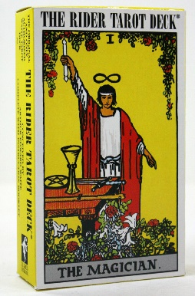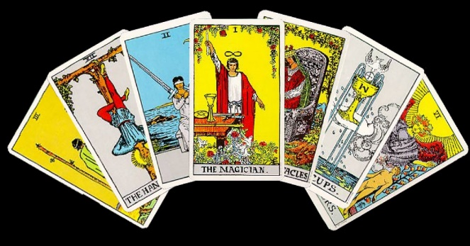

“Journey Through the Tarot”
Learning to Read Tarot Cards

Join Tina DeMottie for an in-depth look at the mysteries of the Tarot. More than just a card reading class, this program is for those who seek to understand the origins and traditions associated with Tarot, which many people use for divination and guidance.

Taught in three parts, Tina will help you understand the Universal Truths the Tarot reveals. You will learn the basic meanings behind each card so you can begin to use the cards as tools for growth and development, both for yourself and for others.

- The first class (March 7) will explain the history of the cards. We will take the "Fools Journey" through the Major Arcana and see how the cards relate to each other.

- The next two classes (April 11 & May 2) will explain the meanings behind the suits of the Minor Arcana, and how to begin to use the cards in spreads and readings.

- You will leave with an understanding and appreciation of the deck, without having to memorize the meanings of all 78 cards.

Tina has studied metaphysics abroad and is a member of the International Tarot Foundation.

Saturdays 10am-12pm
March 7th, April 11th & May 2nd ($40 per class)

SPIRIT HEALING AND WELLNESS
50 Main Street (top floor), Chester, NJ

Registration is required. Please contact Lynn Pridmore to register:
Lynn@SpiritHealingAndWellness.com or 201-572-7771

Be prepared to deepen your spiritual development, as well as have fun!
Please bring the Rider-Waite Tarot deck to class.

