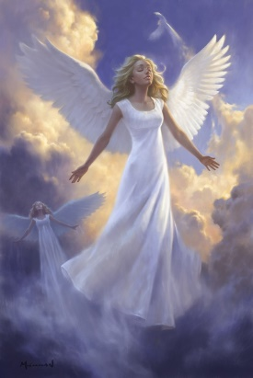 AN EVENING WITH THE ANGELS!

Join Angel Therapy Practitioner, Irene Sonja Fanane for “An Evening with the Angels!” In this class, Irene will:

- Facilitate a high vibrational spiritual discussion
- Lead a guided meditation
- Invoke the presence of an Angel
- Deliver a unique, channeled Angel Message to each participant.

AN EVENING WITH THE ANGELS!
Thursday, April 16th
7:00 - 8:30 pm
$30 per person (cash or check please)

at SPIRIT HEALING AND WELLNESS
50 Main Street (top floor), Chester, NJ

Registration is required. Please contact Lynn Pridmore to register:
Lynn@SpiritHealingAndWellness.com or 201-572-7771

We hope you will join us for this wonderful event!

Irene Sonja is the creator and founder of Awakening to Angels. In addition to being an Angel Therapy Practitioner, Irene is also a mystic channel, medium and spiritual teacher.

