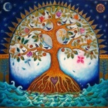
SPIRIT HEALING AND WELLNESS

FALL CLASSES

To assist and support in Knowing Ourselves as the Masters of our own lives, a few new classes have been added to our Fall calendar. Their dates and brief descriptions are listed below.

Contact Lynn at 201-572-7771 or Lynn@SpiritHealingAndWellness.com for additional information, or visit our website at SpiritHealingAndWellness.com.
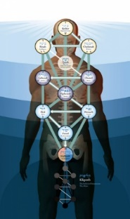

“AWAKENING THE TREE OF LIFE“ The Tree of Life, rooted in the Kabbalah, holds the Keys to living a Heaven-filled life on Earth. Returning you to your innate nature of the Divine, the Tree of Life follows a systematic Journey through the energies of the body to unlock the powerful and loving aspects of our Creator.
In this class, Lynn Pridmore will guide you through each sphere of this Ancient, Sacred Symbol. In addition to the lesson and handout, each class will contain a guided meditation, singing bowls, tuning forks and crystals. These tools are designed to gently assist your body and mind in creating the space for the Divine to flow more freely and fully through you. The meditation will be emailed to each participant, for continued unfoldment within, as well as for reinforcement of the lesson.
“AWAKENING THE TREE OF LIFE”
THURSDAYS, 7-9 pm ($45)
CLASS DATES:

9/6, 9/27, 10/18, 11/15, 12/6, 1/3, 1/24, 2/21, 3/14, 4/4, 4/25
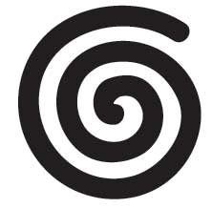
“THE JOURNEY WITHIN”
A COMMUNITY OF LEARNING, FUN, CONNECTION & SUPPORT FOR TEENAGE GIRLS

A new class for 14 &15 year-old girls. A place where to are able to safely express, discover and embrace themselves.

In addition to discussing teenage topics, a variety of holistic, easy-to-implement tools will be shared with the girls, including meditation, mindfulness, yoga, qigong, self-healing energy work, transformational mindsets and more.

Dates and times are based upon the availability of participants. Newcomers are always welcome!

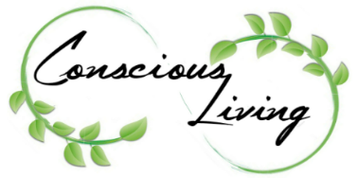
“CONSCIOUS CONVERSATIONS” This class is designed to assist in deepening or developing your practice of Conscious Living. Our welcoming community meets weekly to discuss Ancient spiritual traditions, Eastern philosophies, mindfulness meditation techniques, modern self-care practices and more.

Whether you already have a spiritual practice or are wondering how to begin one, this class is designed to share thoughts, views, philosophies and ideas to consciously live with more purpose, power, fulfillment and joy.

“CONSCIOUS CONVERSATIONS” MONDAYS 10-11:30 AM and THURSDAYS 7-8:30 PM ($25)
JOIN US ANYTIME!

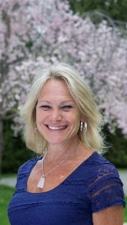
SERVICES BY APPOINTMENT ~ As a Holistic Health Practitioner and Educator specializing in Energy Medicines and Ancient Traditions, Lynn offers a wide variety of services for individuals and groups. Call for additional information, or to schedule an appointment.

LIST OF SERVICES:
Energy Medicine Healing Sessions Jin Shin Jyutsu
Reiki
Integrated Energy Therapy (IET) Vibrational Sound Therapies Indian Head Massage
Tree of Life Activations
Crystal Healing Therapy
Stress Management Training Holistic Health & Empowerment Coaching
Reiki & IET Practitioner Certification
Yoga & Qigong Personal Training Mindfulness & Meditation Training
Personal Guided Meditations Akashic Record Readings Weddings, Baptisms, Funerals

STAY CURRENT! ~ Be sure to join our MeetUp Group! (MeetUp.com/Spirit-Healing-and-Wellness/). Check our website Calendar of Events regularly to stay current of our all our activities, events and fun! (SpiritHealingAndWellness.com).

