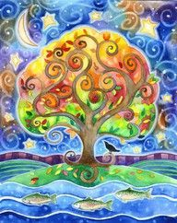
“AWAKENING THE TREE OF LIFE”

A transformational class
held at Spirit Healing and Wellness

”THE SACRED TREE RESIDES IN THEE”

In Kabbalah there’s a Tree,
Which holds the Sacred Keys,
Of living Heaven, here on Earth,
Of Knowing our True Worth.

This Tree is laid out as a Map
Within our human form,
Created by a Flash of Light
In All who have been born.

Ten Holy Spheres of Energy
Create a Path, which leads
To higher forms of Consciousness,
To endless Love and Peace.

The Ancients shared the Keys with us,
As Letters, Chants and Numbers.
All designed to wake us from
Our earthly, human slumber.

Unlock the Temples One by One
And watch your life transform.
Come with me, explore The Tree,
And live the life you’ve dreamed.

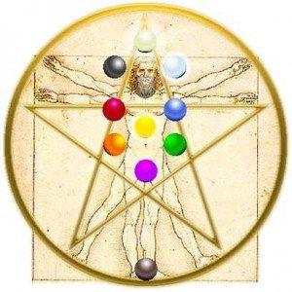
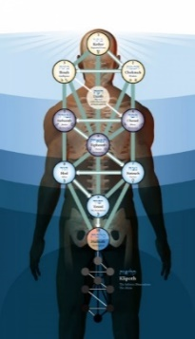
The Tree of Life, rooted in the Kabbalah, holds the Keys to living a Heaven-filled life on Earth. Returning us to our innate nature of the Divine, the Tree of Life follows a systematic Journey through the energies of the body to unlock the powerful and loving aspects of our Creator. Wisdom, Understanding, Loving Kindness, Severity, Beauty, Eternity, Splendor and Foundation…the Gifts of the Creator become unleashed within, resulting in the creation of our Personal Kingdoms.
In this class, Lynn Pridmore will guide you through each sphere of this Ancient, Sacred Symbol. In addition to the lesson and handout, each class will contain a guided meditation, singing bowls, tuning forks and crystals. These tools are designed to gently assist your body and mind in creating the space for the Divine to flow more freely and fully through you. The meditation will be emailed to each participant, for continued unfoldment within, as well as for reinforcement of the lesson.
“AWAKENING THE TREE OF LIFE”

The Group meets every 3 weeks
on a Thursday evening, 7-9 pm ~ $45 per class

Class dates: 9/6, 9/27, 10/18, 11/15, 12/6, 1/3 1/24, 2/21, 3/14, 4/4, 4/25

To register or for additional information, contact Lynn at Lynn@SpiritHealingAndWellness.com or 201-572-7771 or visit our website www.SpiritHealingAndWellness.com

