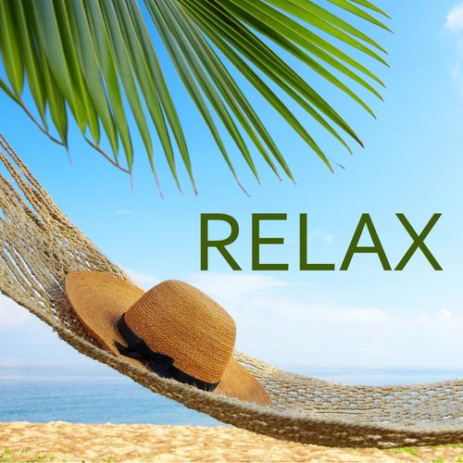  - Simple StresS Management Tools!  Learn a variety of natural, holistic, easy-to-implement practices and bring more peace and harmony into your life!  In this weekly class, Holistic Health Practitioner Lynn Pridmore will share numerous practices to help reduce the effects of conditions such as Anxiety, Depression, Weight Gain, Addiction, Inflammation, High Blood Pressure, High Cholesterol, Insomnia and Procrastination. These practices will help to enhance Mental Health, Memory, Focus & Concentration, Optimism, Digestion, Will Power, Immunity, Emotional Stability, Happiness, Joy and more! Join us weekly or as your schedule allows! | MINDFULNESS & MEDITATION  ____  BREATHWORK & ENERGY WORK  ____  GUIDED IMAGERY & VISUALIZATION  ____  YOGA & QIGONG  ____  WEDNESDAY  EVENINGS  7:00-8:30  $25  SPIRIT HEALING & WELLNESS  50 Main St (Top Floor)  Chester, NJ 07930  Contact Lynn:  201-572-7771  Lynn@SpiritHealingand Wellness.com
Visit www.SpiritHealingAndWellness.com for additional information!

