A SAMPLING OF SERVICES AT SPIRIT HEALING AND WELLNESS!
Treat yourself to a variety of services offered in a nurturing, inviting and loving setting at Spirit Healing and Wellness, 50 Main Street in Chester, NJ (top floor).
Below is a sampling of the many treatments available, in addition to Spiritual Counseling, Empowerment Coaching, and many other services. Contact Lynn Pridmore at lynn@spirithealingandwellness.com or 201-572-7771 to schedule an appointment!
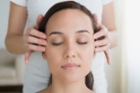 AYURVEDIC INDIAN HEAD MASSAGE ~ Indian Head Massage (IHM) is an ancient technique of manipulating soft tissues in the neck, shoulders, upper chest, upper back, head, scalp, face, arms, hands and fingers. IHM helps to reduce anxiety, stress, mental fatigue, irritability, depression, sinus problems, neuralgia, and insomnia. One treatment increases clarity, focus, concentration, confidence, relaxation, skin glow, oxygen and energy flow. It also balances the chakras, as well as the left and right hemispheres of the brain. A wide variety of massage pressures and rhythms are used during a session. Client remains clothed and sit in a chair for this relaxing, invigorating and energizing treatment.
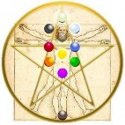TREE OF LIFE AWAKENING ACTIVATION ~ The ancient text of the Kabbalah teaches that the Creator used the sacred geometrical structure of the Tree of Life as the blueprint to construct the Universe. Divinely created, our human bodies contain the EXACT same sacred geometrical pattern. When this structure is activated within an individual, the template of the Tree of Life is awakened, reuniting the individual with their true Divine Nature and the Divine Creator Power within them. This powerful activation brings about higher levels of consciousness, wholeness, balance and unity. Enhanced abilities to create and manifest also result after the Tree is awakened. Client remains clothed for this one-hour session.
INTEGRATED ENERGY THERAPY (IET) ~ IET is a healing modality designed to remove “the issues from the tissues.” IET honors the Traditional Chinese Medicine philosophy that the physical body holds spiritual, mental and emotional aspects (i.e., the liver holds anger, the kidneys hold fear, etc. Working with the DNA and cellular memory areas of the body, IET safely and gently releases limiting energy patterns, thoughts, memories and beliefs. Clearing these areas creates the space to create and store new empowering and life-enhancing thoughts, beliefs and ways of being. Client remains fully clothed on a massage table for an IET session.
JIN SHIN JYUTSU ~ This ancient Japanese healing art utilizes energy points within the body to redirect and unblock the natural flow of energy, thereby enhancing the natural flow of health and wellness. A systematic sequence of hand positions stimulates the circulation and flow of energy, allowing increased vibrancy, health, relaxation, happiness and abundance to naturally flow. Jin Shin Jyutsu is frequently offered in hospitals to patients pre- and post-surgery, to accelerate the recovery period. Client remains clothed during the session and reclines on a practitioner table.
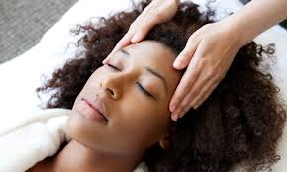 REIKI ~ This gentle healing art activates the natural healing process of the body to restore physical and emotional well-being. Reiki is great for reducing stress and physical pain. It helps to promote peace, balance, harmony and overall health and wellness. Client remains fully clothed and relaxes on a massage table.
A SAMPLING OF SERVICES AT SPIRIT HEALING AND WELLNESS!
Treat yourself to a variety of services offered in a nurturing, inviting and loving setting at Spirit Healing and Wellness, 50 Main Street in Chester, NJ (top floor).
Below is a sampling of the many treatments available, in addition to Spiritual Counseling, Empowerment Coaching, and many other services. Contact Lynn Pridmore at lynn@spirithealingandwellness.com or 201-572-7771 to schedule an appointment!
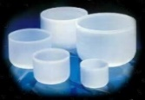 SOUND VIBRATIONAL HEALING THERAPY ~ Tuning forks and crystal singing bowls are placed on and around the body, triggering the body’s natural healing response. Sound Vibrational Healing is often used for stress management, insomnia, anxiety, depression, PTSD and pain management. Sound Therapy brings about inner peace, stillness and bliss, and helps to elevate one to higher states of consciousness. Client relaxes on a massage table and remains fully clothed.
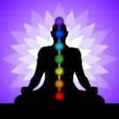 CHAKRA AND AURIC FIELD BALANCING ~ Sound Vibrational Healing, Crystal Energy Therapy, hands-on gentle art healing modalities and more are utilized harmoniously to bring wholeness, balance, clarity and peace to the client, while they relax fully clothed on a practitioner table.
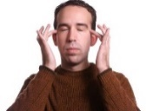EMOTIONAL FREEDOM TECHNIQUE (EFT) ~ Using the fingers to “tap” on the same points accessed by acupuncturists, EFT is a simple, highly-effective tool for transforming emotional blocks and limitations. EFT is frequently used to manage pain, weight and stress. It is also used to overcome addictions, fears, phobias, anxiety and depression. EFT is a wonderful tool to increase confidence, empowerment and implement goals. Client sits fully clothed and taps on his or her own body.
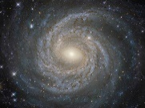 AKASHIC RECORD, PSYCHIC AND SPIRIT READINGS ~ The Akashic Records contain the blueprint or record of each soul. Opening one’s records helps to provide wisdom, direction, understanding and peace. Channeled Psychic and Spiritual Readings are similar, as they offer insight, intuitive guidance, clarity, knowledge and information to encourage personal growth and empowerment, A sacred, holy and trusting space is created for all Readings, where the client is encouraged to ask questions on a variety of matters. Client sits in a chair during the Reading.
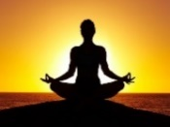 PERSONALIZED GUIDED MEDITATION ~ Whether it’s peace, harmony, empowerment, confidence or self-love, Lynn will lovingly guide you through a personal meditation designed specifically for you. A recording of your personal meditation will be provided for your future enjoyment and listening.
HOLISTIC HEALTH COACHING ~ As a Certified Holistic Health Practitioner, allow Lynn to guide you in healing the mind, body, spirit with the mind, body and spirit. Natural, whole-istic approaches are recommended to bring harmony, balance and wellness to you.

