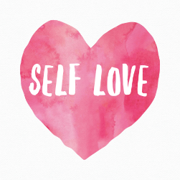“ENDING SELF-SABOTAGE ~ SETTING YOURSELF FREE” 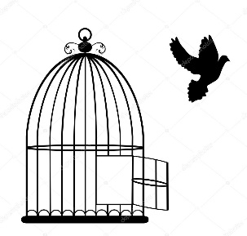

Do you set plans and goals in health or career and seldom seem to achieve them?
Do you fear commitment, change or rejection, and as a result do you settle?
Do you indulge, procrastinate, avoid or deny… losing sight of your vision and dreams?

Unconscious, limiting thoughts and behaviors have been running, ruining and sabotaging your life and it’s time to reclaim your power!

In this weekly class, you will:
- Explore self-defeating thoughts, beliefs, behaviors and patterns.
- Identify inner conflicts created by self-sabotage.
- Create healthier behaviors and strategies which will allow you to live more powerfully and authentically.

“Ending Self-Sabotage ~ Setting Yourself Free” meets:

Monday Mornings 10-11:30
Spirit Healing and Wellness
50 Main Street (top floor), Chester, NJ
$25 class fee
Join us weekly or as your schedule allows!

Contact Lynn Pridmore at lynn@spirithealingandwellness.com or 201-572-7771 for more info.

Only you hold the key to setting yourself free.
Commit to your personal happiness and fulfillment … Put an end to self-sabotage.

